

**CAPSTONE PROJECT REPORT**

**Report 4 – Software Design Document**

– Thủ Đức, November 202 –

**Table of Contents**

I. Project Report **6**

1. Status Report 6

2. Team Involvements 6

3. Issues/Suggestions 6

II. Software Design Document **7**

1. Overall Description 7

1.1 Assumptions 7

1.2 Design Constraints 7

1.3 Technology Suggestion 7

2. System Architecture Design 8

2.1 Overall Architecture 8

2.2 System Architecture 9

2.3 Package Diagram 9

a. Back-end package diagram 9

Figure :  Package Diagram - Back-end 9

a. Front-end package diagram 10

Figure :  Package Diagram - Front-end 10

3. System Detailed Design 10

3.1 Authentication 11

a. Class Diagram 11

b. Class Specification 11

b1. AuthenController 11

b2. User 11

b3. Roles 12

c. Sequence Diagram(s) 13

3.2 Manage User 13

a. Class Diagram 13

b. Class Specification 14

b1. UserController 14

b2. User 14

b3. Roles 14

c. Sequence Diagram(s) 15

3.3 Manage Test Case 15

a. Class Diagram 15

b. Class Specification 15

b1. CaseController 15

b2. User 15

b3. Roles 16

c. Sequence Diagram(s) 17

3.4 Manage Test Run 17

a. Class Diagram 17

b. Class Specification 17

b1. RunController 17

b2. User 17

b3. Roles 18

c. Sequence Diagram(s) 19

3.5 Manage Test Plan 19

a. Class Diagram 19

b. Class Specification 19

b1. PlanController 19

b2. User 19

b3. Roles 20

c. Sequence Diagram(s) 21

3.6 Manage Milestones 21

a. Class Diagram 21

b. Class Specification 21

b1. MilestoneController 21

b2. User 21

b3. Roles 21

c. Sequence Diagram(s) 22

3.7 Manage Report 22

a. Class Diagram 22

b. Class Specification 22

b1. ReportController 22

b2. User 23

b3. Roles 23

c. Sequence Diagram(s) 24

3.8 Manage Project 24

a. Class Diagram 24

b. Class Specification 24

b1. ProjectController 24

b2. User 24

b3. Roles 25

c. Sequence Diagram(s) 26

4. Data & Database Design 26

4.1 Database Design 26

a. User 26

b. Role 28

c. Project Member 28

d. Priorities 28

e. Milestone 29

f. Reports 29

g. Section 29

h. Test Case 30

i. Test Run 30

j. Test Plan 31

k. Status 31

l. Project 31

4.2 Data File Design 31

# I. Project Report

## 1. Status Report

| **#** | **Work Item** | **Status** | **Notes (Work Item in Details)** |
| --- | --- | --- | --- |
| 1 |  | Pending |  |
| 2 |  | In Progress |  |
| 3 |  | Completed |  |

## 2. Team Involvements

| **#** | **Task** | **Member** | **Notes (Task Details, etc.)** |
| --- | --- | --- | --- |
| 1 |  | KienNT |  |
| 2 |  | TuanTV |  |
| 3 |  | AnhLM |  |
| 4 |  |  |  |

## 3. Issues/Suggestions

| **#** | **Issue** | **Status** | **Notes (Solution, Suggestion, etc.)** |
| --- | --- | --- | --- |
| 1 |  | Pending |  |
| 2 |  | In Progress |  |
| 3 |  | Completed |  |

# II. Software Design Document

## 1. Overall Description

### 1.1 Assumptions

* Internet connection: Cable, Wifi
* Operation system: Windows 10
* Computer processor: Intel Core I3
* Computer memory: 4GB or more
* Web browser: Chrome, IE
* IDE: Visual Studio, Visual Studio Code
* DBMS: SQL Server 2019
* Modeling: Draw.io
* Source control: Git on IDE

### 1.2 Design Constraints

* Internet connection:
  + Cable
  + Wi-fi (50Mbps or more)
* Opera system:
  + Windows 10
* Computer processor: Intel core i3
* Computer memory: 4GB or more
* Web browser:
  + Chrome
  + IE (version 11 or more)
* IDE: Visual studio 2019, Visual studio code
* DBMS: SQL Server 2019
* Modeling: Draw.io
* Source control: Git on IDE
  + GitHub

### 1.3 Technology Suggestion

## 2. System Architecture Design

### 2.1 Overall Architecture

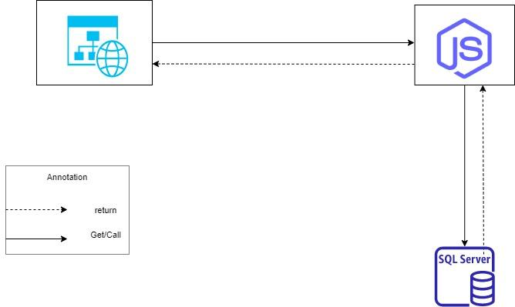

Figure 1:  System Architecture 3-Tier - Overall Architecture

### 2.2 System Architecture

### 2.3 Package Diagram

#### a. Back-end package diagram

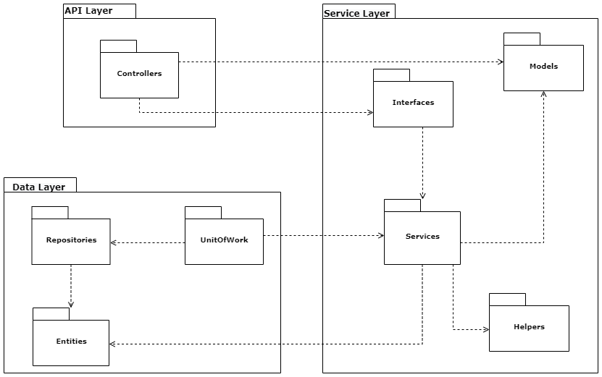

#### Figure :  Package Diagram - Back-end

| **No** | **Package** | **Description** |
| --- | --- | --- |
| *01* | *Controllers* | *The package contains all controller classes* |
| *02* | *Interfaces* | *The package contains all Interface classes* |
| *03* | *Models* | *The package contains all Model classes* |
| *04* | *Services* | *The package contains all Service classes* |
| *05* | *Helpers* | *The package contains all Helper classes* |
| *06* | *Repositories* | *The package contains all Repository classes* |
| *07* | *UnitOfWork* | *The Package contains all controller classes* |
| *08* | *Entities* | *The package contains all Entity classes* |

#### 

#### a. Front-end package diagram

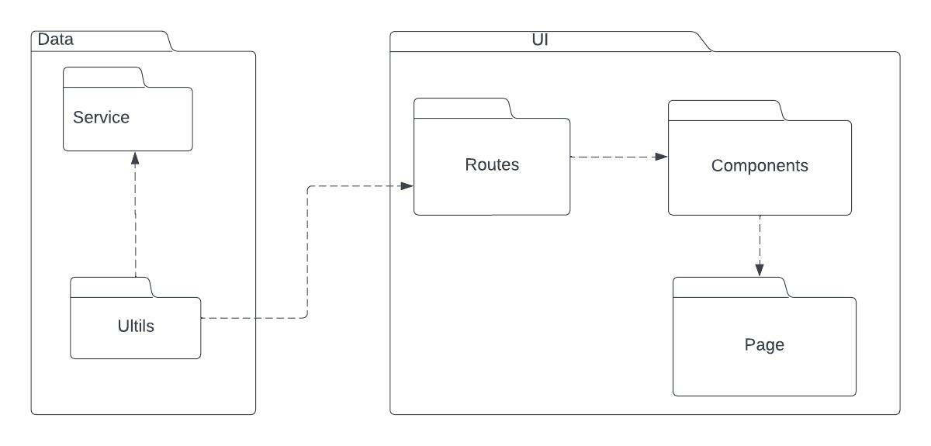

#### Figure :  Package Diagram - Front-end

| **No** | **Package** | **Description** |
| --- | --- | --- |
| 01 | Services | The package contains all service classes |
| 02 | Utils | The package contains utility methods for common use |
| 03 | Routers | The package contains router method for common use |
| 04 | Components | The package contains all component classes |
| 05 | Pages | The package contains all page view for common use |

#### 

## 3. System Detailed Design

### 3.1 Authentication

#### a. Class Diagram

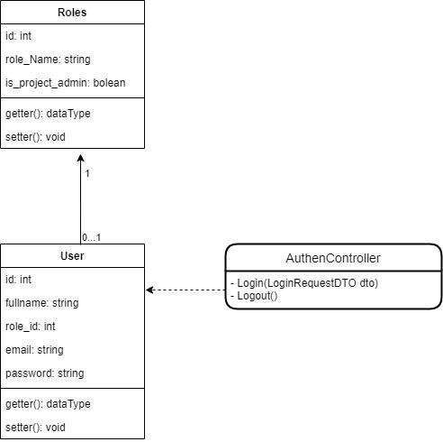

#### b. Class Specification

##### b1. AuthenController

*[Provide the detailed description for the class methods]*

| **No** | **Method** | **Description** |
| --- | --- | --- |
| 01 | Login | * Allow User to login to TMS with following field: + Email: String, required + Password: String, required |
| 02 | Logout | * Allow User logout of TMS |

##### b2. User

| **No** | **Attribute** | **Modify and type** | **Description** |
| --- | --- | --- | --- |
| 01 | id | private int | Unique identifier of a role |
| 02 | fullname | private string | Name of a user |
| 03 | email | private string | Email of a user |
| 04 | password | private string | Password of a user |

| **No** | **Method** | **Description** |
| --- | --- | --- |
| 01 | getter() | Get attribute value |
| 02 | setter() | Set attribute value |

##### b3. Roles

| **No** | **Attribute** | **Modify and type** | **Description** |
| --- | --- | --- | --- |
| 01 | id | private int | Unique identifier of a user |
| 02 | role_Name | private string | Name of a role |
| 03 | is_project_admin | private bool | Attribute representing whether the admin or not |

| **No** | **Method** | **Description** |
| --- | --- | --- |
| 01 | getter() | Get attribute value |
| 02 | setter() | Set attribute value |

#### c. Sequence Diagram(s)

### 3.2 Manage User

#### a. Class Diagram

#### b. Class Specification

##### b1. UserController

| **No** | **Method** | **Description** |
| --- | --- | --- |
| 01 | Login | * Allow User to login to TMS with following field: + Email: String, required + Password: String, required |
| 02 | Logout | * Allow User logout of TMS |

##### b2. User

| **No** | **Attribute** | **Modify and type** | **Description** |
| --- | --- | --- | --- |
| 01 | id | private int | Unique identifier of a role |
| 02 | fullname | private string | Name of a user |
| 03 | email | private string | Email of a user |
| 04 | password | private string | Password of a user |

| **No** | **Method** | **Description** |
| --- | --- | --- |
| 01 | getter() | Get attribute value |
| 02 | setter() | Set attribute value |

##### b3. Roles

| **No** | **Attribute** | **Modify and type** | **Description** |
| --- | --- | --- | --- |
| 01 | id | private int | Unique identifier of a user |
| 02 | role_Name | private string | Name of a role |
| 03 | is_project_admin | private bool | Attribute representing whether the admin or not |

| **No** | **Method** | **Description** |
| --- | --- | --- |
| 01 | getter() | Get attribute value |
| 02 | setter() | Set attribute value |

#### c. Sequence Diagram(s)

### 3.3 Manage Test Case

#### a. Class Diagram

#### b. Class Specification

##### b1. CaseController

| **No** | **Method** | **Description** |
| --- | --- | --- |
| 01 | Login | * Allow User to login to TMS with following field: + Email: String, required + Password: String, required |
| 02 | Logout | * Allow User logout of TMS |

##### b2. Test Case

| **No** | **Attribute** | **Modify and type** | **Description** |
| --- | --- | --- | --- |
| 01 | id | private int | Unique identifier of a role |
| 02 | fullname | private string | Name of a user |
| 03 | email | private string | Email of a user |
| 04 | password | private string | Password of a user |

| **No** | **Method** | **Description** |
| --- | --- | --- |
| 01 | getter() | Get attribute value |
| 02 | setter() | Set attribute value |

##### b3. Roles

| **No** | **Attribute** | **Modify and type** | **Description** |
| --- | --- | --- | --- |
| 01 | id | private int | Unique identifier of a user |
| 02 | role_Name | private string | Name of a role |
| 03 | is_project_admin | private bool | Attribute representing whether the admin or not |

| **No** | **Method** | **Description** |
| --- | --- | --- |
| 01 | getter() | Get attribute value |
| 02 | setter() | Set attribute value |

#### c. Sequence Diagram(s)

### 3.4 Manage Test Run

#### a. Class Diagram

#### b. Class Specification

##### b1. RunController

| **No** | **Method** | **Description** |
| --- | --- | --- |
| 01 | Login | * Allow User to login to TMS with following field: + Email: String, required + Password: String, required |
| 02 | Logout | * Allow User logout of TMS |

##### b2. Test Run

| **No** | **Attribute** | **Modify and type** | **Description** |
| --- | --- | --- | --- |
| 01 | id | private int | Unique identifier of a role |
| 02 | fullname | private string | Name of a user |
| 03 | email | private string | Email of a user |
| 04 | password | private string | Password of a user |

| **No** | **Method** | **Description** |
| --- | --- | --- |
| 01 | getter() | Get attribute value |
| 02 | setter() | Set attribute value |

##### b3. Roles

| **No** | **Attribute** | **Modify and type** | **Description** |
| --- | --- | --- | --- |
| 01 | id | private int | Unique identifier of a user |
| 02 | role_Name | private string | Name of a role |
| 03 | is_project_admin | private bool | Attribute representing whether the admin or not |

| **No** | **Method** | **Description** |
| --- | --- | --- |
| 01 | getter() | Get attribute value |
| 02 | setter() | Set attribute value |

#### c. Sequence Diagram(s)

### 3.5 Manage Test Plan

#### a. Class Diagram

#### b. Class Specification

##### b1. PlanController

| **No** | **Method** | **Description** |
| --- | --- | --- |
| 01 | Login | * Allow User to login to TMS with following field: + Email: String, required + Password: String, required |
| 02 | Logout | * Allow User logout of TMS |

##### b2. Test Plan

| **No** | **Attribute** | **Modify and type** | **Description** |
| --- | --- | --- | --- |
| 01 | id | private int | Unique identifier of a role |
| 02 | fullname | private string | Name of a user |
| 03 | email | private string | Email of a user |
| 04 | password | private string | Password of a user |

| **No** | **Method** | **Description** |
| --- | --- | --- |
| 01 | getter() | Get attribute value |
| 02 | setter() | Set attribute value |

##### b3. Roles

| **No** | **Attribute** | **Modify and type** | **Description** |
| --- | --- | --- | --- |
| 01 | id | private int | Unique identifier of a user |
| 02 | role_Name | private string | Name of a role |
| 03 | is_project_admin | private bool | Attribute representing whether the admin or not |

| **No** | **Method** | **Description** |
| --- | --- | --- |
| 01 | getter() | Get attribute value |
| 02 | setter() | Set attribute value |

#### c. Sequence Diagram(s)

### 3.6 Manage Milestones

#### a. Class Diagram

#### b. Class Specification

##### b1. MilestoneController

| **No** | **Method** | **Description** |
| --- | --- | --- |
| 01 | Login | * Allow User to login to TMS with following field: + Email: String, required + Password: String, required |
| 02 | Logout | * Allow User logout of TMS |

##### b2. Milestone

| **No** | **Attribute** | **Modify and type** | **Description** |
| --- | --- | --- | --- |
| 01 | id | private int | Unique identifier of a role |
| 02 | fullname | private string | Name of a user |
| 03 | email | private string | Email of a user |
| 04 | password | private string | Password of a user |

| **No** | **Method** | **Description** |
| --- | --- | --- |
| 01 | getter() | Get attribute value |
| 02 | setter() | Set attribute value |

##### b3. Roles

| **No** | **Attribute** | **Modify and type** | **Description** |
| --- | --- | --- | --- |
| 01 | id | private int | Unique identifier of a user |
| 02 | role_Name | private string | Name of a role |
| 03 | is_project_admin | private bool | Attribute representing whether the admin or not |

| **No** | **Method** | **Description** |
| --- | --- | --- |
| 01 | getter() | Get attribute value |
| 02 | setter() | Set attribute value |

#### c. Sequence Diagram(s)

### 3.7 Manage Report

#### a. Class Diagram

#### b. Class Specification

##### b1. ReportController

| **No** | **Method** | **Description** |
| --- | --- | --- |
| 01 | Login | * Allow User to login to TMS with following field: + Email: String, required + Password: String, required |
| 02 | Logout | * Allow User logout of TMS |

##### b2. Report

| **No** | **Attribute** | **Modify and type** | **Description** |
| --- | --- | --- | --- |
| 01 | id | private int | Unique identifier of a role |
| 02 | fullname | private string | Name of a user |
| 03 | email | private string | Email of a user |
| 04 | password | private string | Password of a user |

| **No** | **Method** | **Description** |
| --- | --- | --- |
| 01 | getter() | Get attribute value |
| 02 | setter() | Set attribute value |

##### b3. Roles

| **No** | **Attribute** | **Modify and type** | **Description** |
| --- | --- | --- | --- |
| 01 | id | private int | Unique identifier of a user |
| 02 | role_Name | private string | Name of a role |
| 03 | is_project_admin | private bool | Attribute representing whether the admin or not |

| **No** | **Method** | **Description** |
| --- | --- | --- |
| 01 | getter() | Get attribute value |
| 02 | setter() | Set attribute value |

#### c. Sequence Diagram(s)

### 3.8 Manage Project

#### a. Class Diagram

#### b. Class Specification

##### b1. ProjectController

| **No** | **Method** | **Description** |
| --- | --- | --- |
| 01 | Login | * Allow User to login to TMS with following field: + Email: String, required + Password: String, required |
| 02 | Logout | * Allow User logout of TMS |

##### b2. Project

| **No** | **Attribute** | **Modify and type** | **Description** |
| --- | --- | --- | --- |
| 01 | id | private int | Unique identifier of a role |
| 02 | fullname | private string | Name of a user |
| 03 | email | private string | Email of a user |
| 04 | password | private string | Password of a user |

| **No** | **Method** | **Description** |
| --- | --- | --- |
| 01 | getter() | Get attribute value |
| 02 | setter() | Set attribute value |

##### b3. Roles

| **No** | **Attribute** | **Modify and type** | **Description** |
| --- | --- | --- | --- |
| 01 | id | private int | Unique identifier of a user |
| 02 | role_Name | private string | Name of a role |
| 03 | is_project_admin | private bool | Attribute representing whether the admin or not |

| **No** | **Method** | **Description** |
| --- | --- | --- |
| 01 | getter() | Get attribute value |
| 02 | setter() | Set attribute value |

#### c. Sequence Diagram(s)

## 4. Data & Database Design

### 4.1 Database Design

*[Provide the tables relationship like example below]*

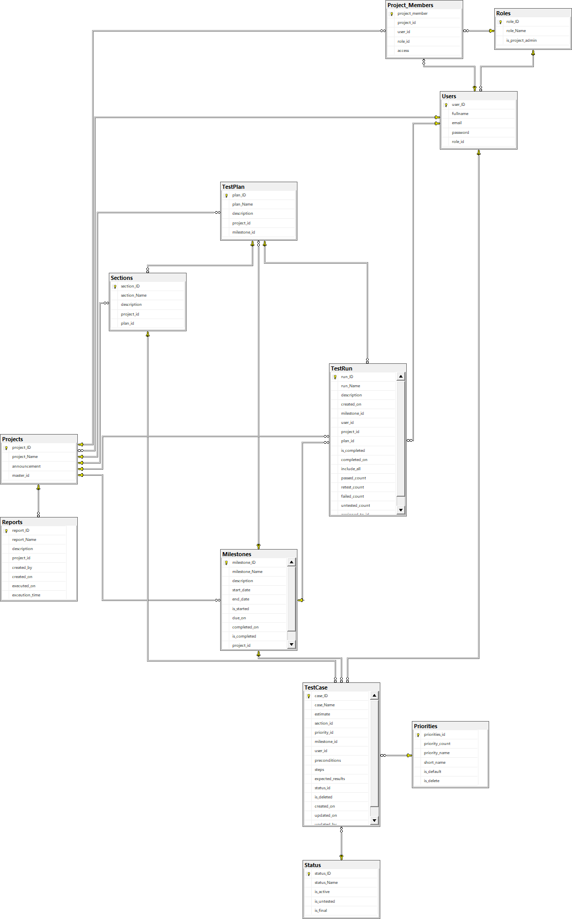

#### a. User

| **Field name** | **Type** | **Size** | **Unique** | **Not Null** | **PK/FK** | **Notes** |
| --- | --- | --- | --- | --- | --- | --- |
| user_id | int |  | X | X | PK |  |
| fullname | nvarchar | 250 |  | X |  |  |
| email | nvarchar | 250 |  | X |  |  |
| password | nvarchar | 250 |  | X |  |  |
| role_id | nvarchar | 250 |  | X | FK |  |

#### b. Role

| **Field name** | **Type** | **Size** | **Unique** | **Not Null** | **PK/FK** | **Notes** |
| --- | --- | --- | --- | --- | --- | --- |
| role_id | int |  | X | X | PK |  |
| role_Name | nvarchar | 250 |  | X |  |  |
| is_project_admin | nt |  |  | X |  |  |

#### c. Project Member

| **Field name** | **Type** | **Size** | **Unique** | **Not Null** | **PK/FK** | **Notes** |
| --- | --- | --- | --- | --- | --- | --- |
| project_member | int |  | X | X |  |  |
| project_id | int |  |  |  | PK |  |
| user_id | int |  |  |  | FK |  |
| role_id | int |  |  |  | FK |  |
| access | nchar | 10 |  |  |  |  |

#### d. Priorities

| **Field name** | **Type** | **Size** | **Unique** | **Not Null** | **PK/FK** | **Notes** |
| --- | --- | --- | --- | --- | --- | --- |
| priorities_id | int |  | X | X | PK |  |
| priority_count | int |  |  | X |  |  |
| priority_name | nvarchar | 250 |  | X |  |  |
| short_name | nvarchar | 250 |  | X |  |  |
| is_default | bit |  |  | X |  |  |
| is_delete | bit |  |  | X |  |  |

#### e. Milestone

| **Field name** | **Type** | **Size** | **Unique** | **Not Null** | **PK/FK** | **Notes** |
| --- | --- | --- | --- | --- | --- | --- |
| milestone_id | int |  | X | X | PK |  |
| milestone_name | nvarchar | 250 |  | X |  |  |
| description | nvarchar | 250 |  | X |  |  |
| start_date | date |  |  |  |  |  |
| end_date | date |  |  |  |  |  |
| is_started | bit |  |  | X |  |  |
| due_on | date |  |  |  |  |  |
| completed_on | date |  |  |  |  |  |
| is_completed | bit |  |  | X |  |  |
| project_id | int |  |  | X | FK |  |

#### f. Reports

| **Field name** | **Type** | **Size** | **Unique** | **Not Null** | **PK/FK** | **Notes** |
| --- | --- | --- | --- | --- | --- | --- |
| report_id | int |  | X | X | PK |  |
| report_Name | nvarchar | 250 |  | X |  |  |
| description | nvarchar | 250 |  |  |  |  |
| project_id | int |  |  | X | FK |  |
| created_by | date |  |  | X |  |  |
| created_on | date |  |  | X |  |  |
| executed_on | date |  |  | X |  |  |
| executed_time | date |  |  | X |  |  |

#### g. Section

| **Field name** | **Type** | **Size** | **Unique** | **Not Null** | **PK/FK** | **Notes** |
| --- | --- | --- | --- | --- | --- | --- |
| section_id | int |  | X | X | PK |  |
| section_name | nvarchar | 250 |  | X |  |  |
| description | nvarchar | 250 |  |  |  |  |
| project_id | int |  |  |  | FK |  |
| plan_id | int |  |  |  | FK |  |

#### h. Test Case

| **Field name** | **Type** | **Size** | **Unique** | **Not Null** | **PK/FK** | **Notes** |
| --- | --- | --- | --- | --- | --- | --- |
| case_id | int |  | X | X | PK |  |
| case_Name | nvarchar |  |  | X |  |  |
| estimate | int |  |  | X |  |  |
| section_id | int |  |  | X | FK |  |
| priority_id | int |  |  | X | FK |  |
| milestone_id | int |  |  |  | FK |  |
| user_id | int |  |  | X | FK |  |
| preconditions | nvarchar | MAX |  |  |  |  |
| steps | nvarchar | MAX |  |  |  |  |
| expected_result | nvarchar | MAX |  |  |  |  |
| status_id | int |  |  |  | FK |  |
| is_deleted | bit |  |  |  |  |  |
| created_on | date |  |  | X |  |  |
| updated_on | date |  |  | X |  |  |
| updated_by | date |  |  | X |  |  |

#### i. Test Run

| **Field name** | **Type** | **Size** | **Unique** | **Not Null** | **PK/FK** | **Notes** |
| --- | --- | --- | --- | --- | --- | --- |
| run_id | int |  | X | X | PK |  |
| run_Name | nvarchar | 250 |  | X |  |  |
| description | nvarchar | 250 |  |  |  |  |
| created_on | date |  |  | X |  |  |
| milestone_id | int |  |  |  | FK |  |
| user_id | int |  |  |  | FK |  |
| project_id | int |  |  |  | FK |  |
| plan_id | int |  |  |  | FK |  |
| is_completed | bit |  |  | X |  |  |
| completed_on | date |  |  | X |  |  |
| include_all | bit |  |  | X |  |  |
| passed_count | int |  |  | X |  |  |
| retest_count | int |  |  | X |  |  |
| failed_count | int |  |  | X |  |  |
| untested_count | int |  |  |  |  |  |
| assigned_to_id | int |  |  |  |  |  |

#### j. Test Plan

| **Field name** | **Type** | **Size** | **Unique** | **Not Null** | **PK/FK** | **Notes** |
| --- | --- | --- | --- | --- | --- | --- |
| plan_id | int |  | X | X | PK |  |
| plan_name | nvarchar | 250 |  | X |  |  |
| description | nvarchar | 250 |  |  |  |  |
| project_id | int |  |  |  | FK |  |
| milestone_id | int |  |  |  | FK |  |

#### k. Status

| **Field name** | **Type** | **Size** | **Unique** | **Not Null** | **PK/FK** | **Notes** |
| --- | --- | --- | --- | --- | --- | --- |
| status_id | int |  | X | X | PK |  |
| status_Name | nvarchar | 250 |  | X |  |  |
| is_active | bit |  |  | X |  |  |
| is_untested | bit |  |  | X |  |  |
| is_final | bit |  |  | X |  |  |

#### l. Project

| **Field name** | **Type** | **Size** | **Unique** | **Not Null** | **PK/FK** | **Notes** |
| --- | --- | --- | --- | --- | --- | --- |
| project_id | int |  | X | X | PK |  |
| project_name | nvarchar | 250 |  | X |  |  |
| announcement | nvarchar | 250 |  |  |  |  |
| master_id | int |  |  |  |  |  |